Pizza sales Queries

1. KPI’s
2. Total revenue:

select sum(total_revenue) as Total_revenue from pizza_sales

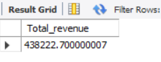S